|  |  |  |
| --- | --- | --- |
| **\\E4039S01sv001.indigo.schools.internal\fsE4039S01-StaffFolders$\e4056171\Desktop\Resources\Best Logo Black and white.JPG** | **Narrogin Senior High School**  **Year 12 Maths Methods**  **2018**  **Task : Investigation 2** | **Result:**  **___/29** |

|  |  |  |  |
| --- | --- | --- | --- |
| Student’s name: |  | Weighting: | 7% |
| Teacher’s name: |  | Time: | 35 min |
| Assessment type: | Investigation | Date: |  |

**Task:**

**Test conditions**

1. Write all answers in the space provided.
2. Follow any instructions that are specific to a particular question (rounding and units).
3. It is recommended that you do not use pencil, except in diagrams.
4. Spare pages can be provided if required.
   * Planning: If you use the spare pages for planning, indicate this clearly at the top of the page.
   * Continuing an answer: If you need to use the space to continue an answer, indicate in the original answer space where the answer is continued, i.e. give the page number. Fill in the number of the question that you are continuing to answer at the top of the page.
5. **Show all working clearly.** Your working should be in sufficient detail to allow your answers to be checked readily and for marks to be awarded for reasoning. Incorrect answers given without supporting reasoning cannot be allocated any marks. For any question or part question worth more than two marks, valid working or justification is required to receive full marks. If you repeat any question, ensure that you cancel the answer you do not wish to have marked.

**To be provided by the candidate**

Standard items: pens (blue/black preferred), pencils (including coloured), sharpener, correction fluid/tape, eraser, ruler, highlighters, SCSA Formula Sheet

Special items:  nil

**Assessment:**

|  |  |  |  |
| --- | --- | --- | --- |
| Section | Number of questions available | Marks available | Percentage of test |
| Section Take Home: | 6 | 0 | 0 |
| Section In-class validation: | 5 | 29 | 100 |
| **Total** | | | 100 |

**Feedback:**

|  |
| --- |
|  |

Prolonged exposure to loud music can result in hearing loss. The two major characteristics of sound are intensity and frequency (pitch). We are only considering intensity of sound, *I*, which is measured inwatts/m 2.

The sound intensity level, *L,*  is a logarithmic measure given as

*L* = 10 log $\left( \frac{I}{I_{0}}\right)$ and measured in decibels (dB)

*I* = 10 -12 watts/m 2.

The reference intensity of sound, *I*, that all other intensities are compared to is

10-12 watts/m2 because this is the weakest intensity of sound that can be detected by the human ear.

**Question 1 [2 marks]**

Determine the sound intensity level of normal piano practice when the intensity of the sound of the music is 10- 5 watts/m 2.

**Question 2 [4, 3 = 7 marks]**

The maximum sound intensity level of an orchestra playing is 110 dB.

1. The sound intensity level of a live performance of a rock band can reach 135 dB**.** Howmany times more intense is the sound of the music of a live rock band than the music of an orchestra? (4 marks)
2. The sound intensity level of chamber music in a small auditorium is around 90 dB. How many times less intense is the sound of the chamber music than the music of an orchestra? (3 marks)

**Question 3 [1, 1 = 2 marks]**

1. Given the range of the sound intensity levels, *L*, of the following musical instruments, which two instruments have the potential to do the most damage to the human ear?

(1 mark)

|  |  |
| --- | --- |
|  | *L* (dB) |
| Violin | 84-102 |
| Cello | 82-93 |
| Oboe | 90-94 |
| Flute | 85-110 |
| Piccolo | 95-112 |
| Clarinet | 92-102 |
| French horn | 90-105 |
| Trombone | 85-114 |
| Timpani and bass drum rolls | 107 |

(b) What other factors need to be considered? (1 mark)

**Question 4 (2, 3, 1, 1, 1, 2, 2 = 12 marks)**

The table below shows the average sound intensity levels (*L*) and the intensity of the sound (*I*) of some instruments of a symphony orchestra. The ratios $\left( \frac{I}{I_{0}}\right)$ are also given for each instrument.

(a) Determine the missing values (i) – (iv) (2 marks)

|  |  |  |  |
| --- | --- | --- | --- |
| musical instrument | average sound intensity level, *L*  *(* dB *)* | $\left( \frac{I}{I_{0}}\right)$ | intensity of sound, *I*  *(* watts/m 2 ) |
| Violin | 93 | 1 995 262 315 | 0.0019953 |
| Cello | 87.5 | (i) | (iii) |
| Oboe | 92 | 1 584 893 192 | 0.0015849 |
| Flute | 97.5 | 5 623 413 252 | 0.0056234 |
| Piccolo | 103.5 | (ii) | (iv) |
| Trombone | 99.5 | 8 912 509 301 | 0.0089125 |
| Timpani and  bass drum rolls | 107 | 50 118 723 360 | 0.0501187 |

(b) Plot the intensity of sound (*I* watts/m 2 )against the average sound intensity level

(*L* dB) for any four of the musical instruments listed in the table above. (3 marks)

0.1000

Intensity

of sound,

*I*

0.0100

0.0010

0.0001

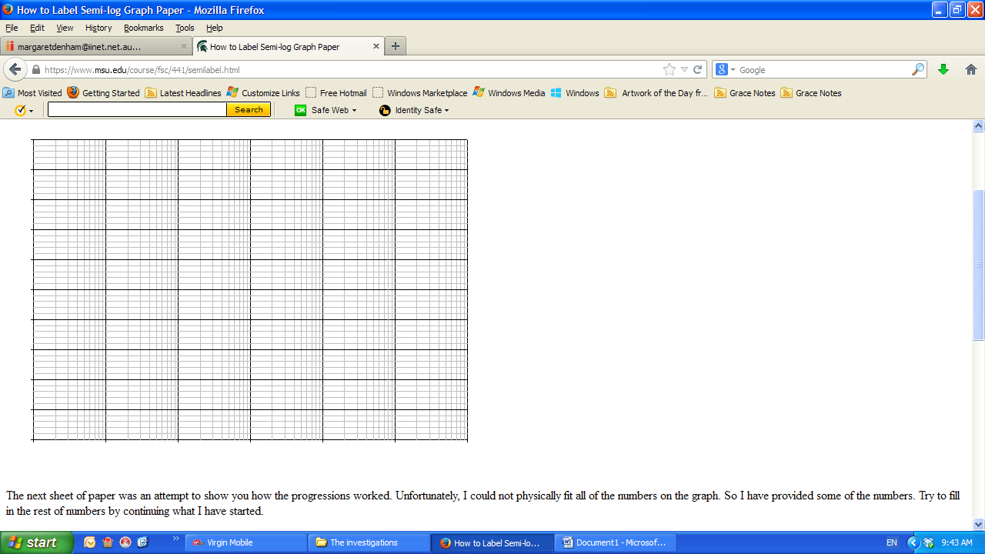

85 90 95 100 105 110

Average sound intensity level, *L*

**Question 4 (continued)**

(c) Identify the relationship between the points you have plotted. (1 mark)

(d) Using the graph or otherwise, determine the average sound intensity level of the sound from a musical instrument that has an intensity of sound of 0.1 watts/m 2. (1 mark)

(e) Explain why a semi – logarithm grid was useful for the data graphed. (1 mark)

(f) What shape would the *L* – *I* graph take? Explain your decision. (2 marks)

**Noise exposure**

It is said that an increase of 3 decibels in sound intensity level will double the intensity of the sound.

**Question 5 [4, 4 = 8 marks]**

(a) By finding an expression for *I* at a sound intensity level of 80 dB and *I* at a sound intensity level of 83 dB, show why increasing the sound intensity level by 3 dBdoubles the value of *I.* (4 marks)

(b) Show how this is the case at any sound intensity level. (4 marks)